Step 1: Enrollment into the Backlog Class
- Email the Center for Student Success (CSS) at CSS@Winona.edu and request enrollment in the backlog class. Please allow up to 48 business hours for CSS to process your enrollment.
- Once enrolled, you will need to approve the placement in the Tevera system.
Step 2: Confirming Placement Details
- Navigate to the Placements environment within Tevera.
- Look for the COE Backlog Placement and click the + button under "School Details." Confirm the placement and submit.
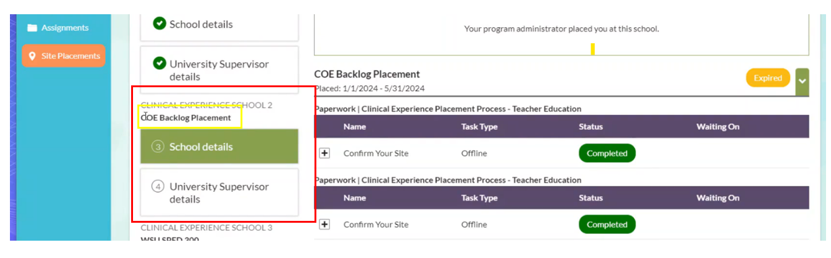

- For "University Supervisor Details," the supervision start date should be the first day of your first semester at WSU, and the supervision end date should be the last day of the current semester. Submit these details. CSS will take approximately 48 business hours to approve the placement.
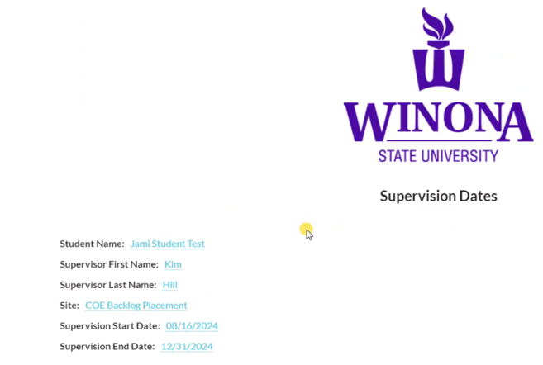

Step 3: Adding Hours
- Go to the Assignments environment and locate the COE Backlog assignments. Click "Backlog Time Track."
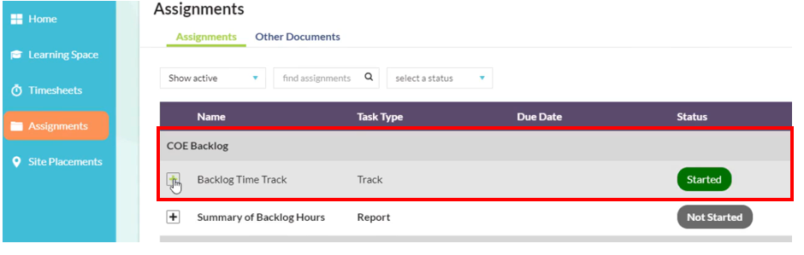

- Ensure the following:
  - COE Backlog time track is selected.
  - Program is listed as Teacher Education.
  - School is listed as COE Backlog Placement.
  - University Supervisor is Kim Hill.
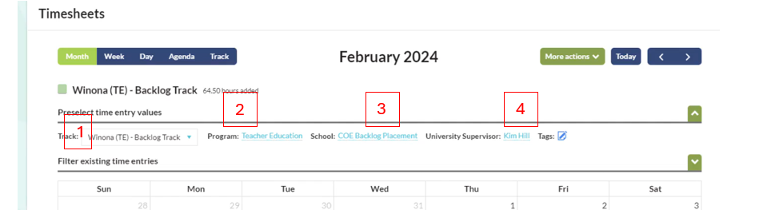

- Begin entering your hours. Organize the clinical placement classes you have taken, the semester they were taken, the associated hours, the cooperating teacher's name, and the school where the hours were completed. For backlogging purposes, enter your hours within the relevant semester, using exact dates if available.
- Enter the date, time, and whether the placement was face-to-face or virtual. Include notes specifying the school name, city, state, the name of the class, and the cooperating licensed teacher’s name.
IMPORTANT: Notes must state the School Name, City, and State, and include the cooperating licensed teacher's name.
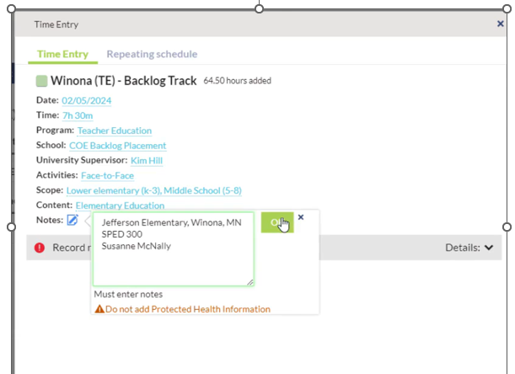

- Once all clinical placement hours for a class are entered, repeat the process for any additional classes until all hours are documented. If exact dates are unknown, enter hours in bulk using the repeating schedules tutorial found here.
Step 4: Running Your Report
- Go to the Assignments environment and click on the “Summary of Backlog Hours” assignment.
- Enter the following:
  - Date Range: From the date you started at WSU to the last date of the current semester.
  - Track: COE Backlog.
  - Signature: Kim Hill.
  - Check the "Include Notes" box.
  - Program: Teacher Education.
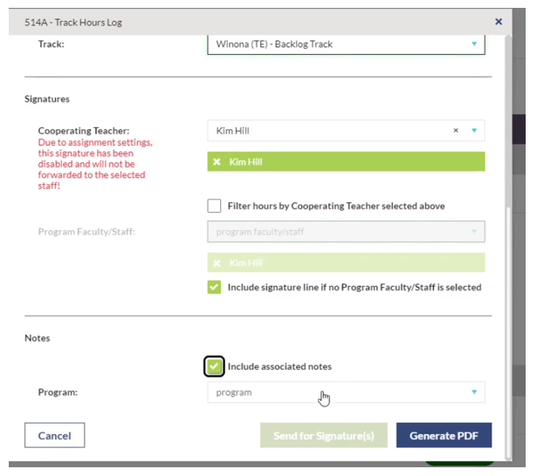

- Click “Send for signatures.” Your report should show your completed hours. Enter your password and click “Sign and Send.”
Submission Confirmation Kim Hill will review and approve your submitted hours. For any questions or further assistance, contact CSS at CSS@winona.edu .

